Project Design Phase-II
Technology Stack (Architecture & Stack)

Date | 30 September 2026
Team ID
Project Name | Script-Controlled ACL – Restrict Record Access Based on Field Value
Maximum Marks | 4 Marks

Technical Architecture:
The Deliverable shall include the architectural diagram as below and the information as per the table1 & table 2
Architecture: Script-Controlled ACL on the ServiceNow platform
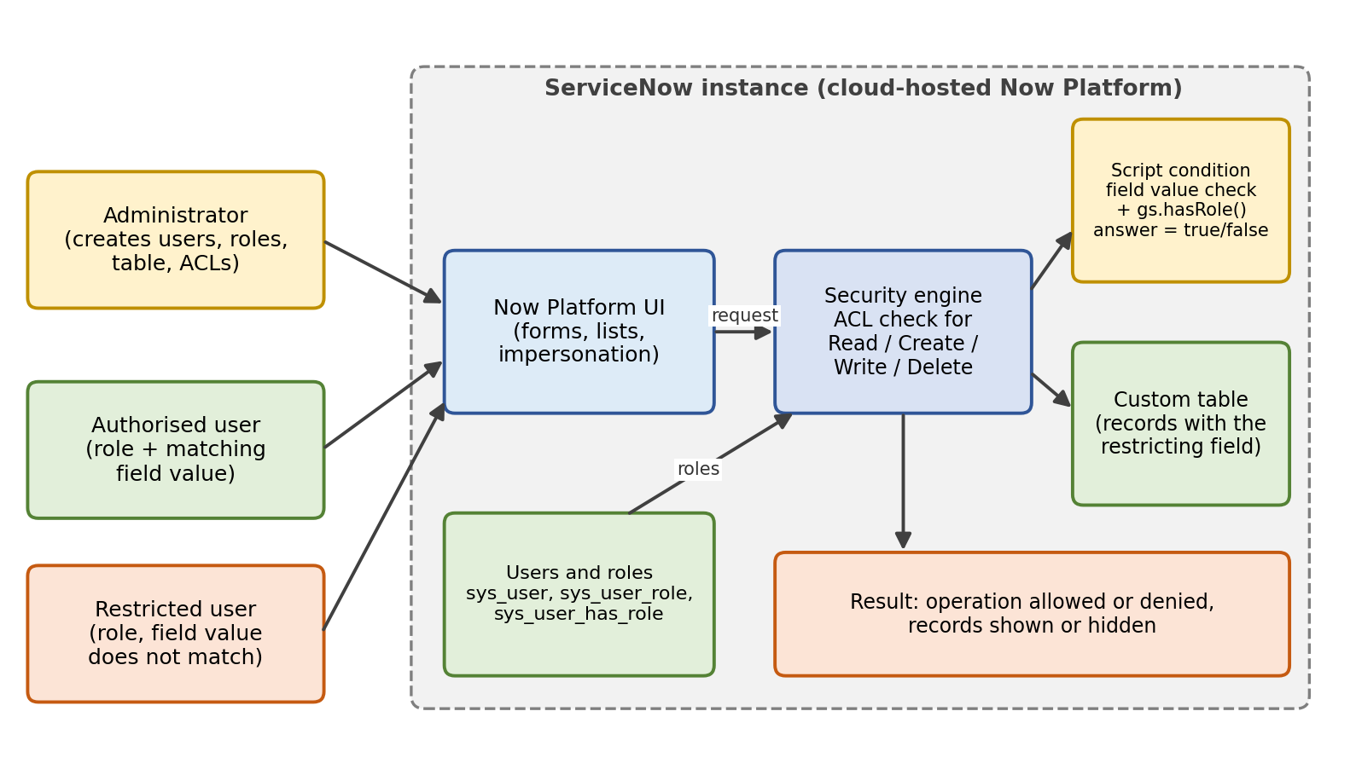
Table-1 : Components & Technologies:
S.No | Component | Description | Technology
 | User Interface | Now Platform UI used by the administrator to build the setup, and by users to open forms and lists. Impersonation is used for testing. | ServiceNow Now Platform UI (forms, lists, impersonate user)
 | Application Logic-1 | Creates the users and roles and assigns roles to users (Milestone 1). | ServiceNow User Administration: sys_user, sys_user_role, sys_user_has_role
 | Application Logic-2 | Read and Create ACLs whose script checks the value of a field on the record and the user's role (Milestones 3 and 4). | ServiceNow ACL (sys_security_acl), Glide server-side JavaScript
 | Application Logic-3 | Write and Delete ACLs with the same field-value script logic (Milestones 5 and 6). | ServiceNow ACL (sys_security_acl), Glide server-side JavaScript
 | Database | Custom table holding the records, with a field whose value controls who may access each record (Milestone 2). | ServiceNow relational database (managed by the platform)
 | Cloud Database | Example: managed cloud database of the ServiceNow instance, holding the custom table and the ACL records. No separate database is set up by the team. | ServiceNow cloud instance database (managed by ServiceNow)
 | File Storage | Example: supporting documents attached to a record (for instance a screenshot of a test result) are kept as record attachments. | ServiceNow attachments (sys_attachment), or Local Filesystem for exports
 | External API-1 | Example: REST call that lists the records a test user can see, used to check that the Read ACL also protects API access. | ServiceNow REST Table API
 | External API-2 | Example: single sign-on so that users sign in with their organisation account before ACLs are evaluated. | Microsoft Entra ID (Azure AD) SSO / SAML 2.0
 | Machine Learning Model | Example: model that suggests the sensitivity value of a new record, so the restricting field is filled in consistently. | ServiceNow Predictive Intelligence (classification model)
 | Infrastructure (Server / Cloud) | Application deployment on a ServiceNow instance hosted in the cloud by ServiceNow.  Local system: any laptop with a web browser (e.g. Chrome) for administrators and testers  Cloud server configuration: e.g. a ServiceNow Personal Developer Instance, managed by ServiceNow | ServiceNow cloud

Table-2: Application Characteristics:
S.No | Characteristics | Description | Technology
 | Open-Source Frameworks | No open-source framework is used. The solution is built with the platform's own scripting and configuration. | ServiceNow Glide API (JavaScript)
 | Security Implementations | Role-based access plus scripted ACLs for Read, Create, Write and Delete. A record is accessible only when the user's role and the record's field value both allow it. Access is checked on the server, and every operation is tested by impersonating users. | ServiceNow roles, ACL scripts, impersonation
 | Scalable Architecture | Rules are stored as ACL records, so the same pattern can be applied to more tables and roles without changing the application. | ServiceNow multi-tenant cloud platform
 | Availability | Availability is provided by the ServiceNow cloud platform that hosts the instance. | ServiceNow cloud
 | Performance | ACL scripts are kept short and only compare the current record's field value with the user's role, so they add little cost to each request. | Glide JavaScript in ACL conditions

References:
https://c4model.com/
https://developer.ibm.com/patterns/online-order-processing-system-during-pandemic/
https://www.ibm.com/cloud/architecture
https://aws.amazon.com/architecture
https://medium.com/the-internal-startup/how-to-draw-useful-technical-architecture-diagrams-2d20c9fda90d

